NAME:P HARISH
REG NO:192524197

3: Design a lexical Analyzer for given language should ignore the redundant spaces, tabs and new lines and ignore comments using C

Program:

C Program – Lexical Analyzer Using File Handling
#include <stdio.h>
#include <stdlib.h>
#include <string.h>
#include <ctype.h>

int isKeyword(char buffer[])
{
char keywords[32][10] =
{
"main", "auto", "break", "case", "char", "const",
"continue", "default", "do", "double", "else", "enum",
"extern", "float", "for", "goto", "if", "int", "long",
"register", "return", "short", "signed", "sizeof",
"static", "struct", "switch", "typedef", "unsigned",
"void", "printf", "while"
};

int i, flag = 0;

for (i = 0; i < 32; ++i)
{
if (strcmp(keywords[i], buffer) == 0)
{
flag = 1;
break;
}
}

return flag;
}

int main()
{
char ch;
char buffer[15];
char operators[] = "+-*/%=";

FILE *fp;
int i, j = 0;

fp = fopen("flex_input.txt", "r");

if (fp == NULL)
{
printf("Error while opening the file\n");
exit(0);
}

while ((ch = fgetc(fp)) != EOF)
{
/* Check for operators */
for (i = 0; i < 6; ++i)
{
if (ch == operators[i])
{
printf("%c is operator\n", ch);
}
}

/* Check for keywords and identifiers */
if (isalnum(ch))
{
buffer[j++] = ch;
}
else if ((ch == ' ' || ch == '\n') && (j != 0))
{
buffer[j] = '\0';
j = 0;

if (isKeyword(buffer) == 1)
{
printf("%s is keyword\n", buffer);
}
else
{
printf("%s is identifier\n", buffer);
}
}
}

fclose(fp);

return 0;
}

Input File: flex_input.txt
main ( ) {
int a, b, c;
c = b + c;
printf ( "%d", c );
}

Output:
main is keyword
int is keyword
a is identifier
b is identifier
c is identifier
c is identifier
= is operator
b is identifier
+ is operator
c is identifier
printf is keyword
% is operator
d is identifier
c is identifier

Program Screenshot:
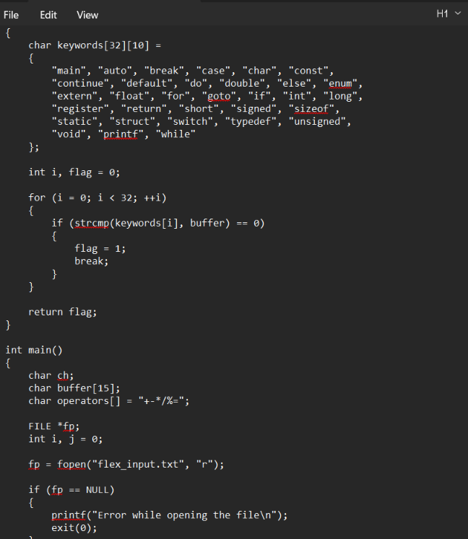

OUTPUT:
